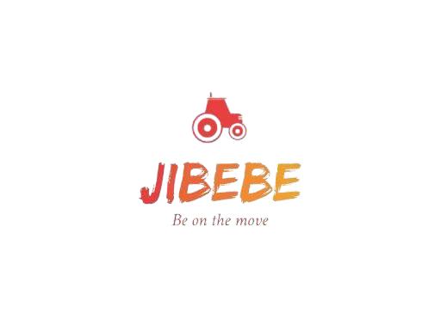

Internship 2022 Progress report format

Name: CYNTHIA KEMBOI

# Tasks completed last week

## ● [#49] Computer Vision

Computer vision is a field of artificial intelligence (AI) that enables computers and systems to derive meaningful information from digital images, videos and other visual inputs, and take actions or make recommendations based on that information. If AI enables computers to think, computer vision enables them to see, observe and understand.

Computer vision works much the same as human vision, except humans have a head start. Human sight has the advantage of lifetimes of context to train how to tell objects apart, how far away they are, whether they are moving and whether there is something wrong in an image.

Computer vision trains machines to perform these functions, but it has to do it in much less time with cameras, data and algorithms rather than retinas, optic nerves and a visual cortex. Because a system trained to inspect products or watch a production asset can analyze thousands of products or processes a minute, noticing imperceptible defects or issues, it can quickly surpass human capabilities.

**Applications**

* Intruder detection
* Defect detection
* Metrology
* Assembly verification
* Screen reading
* CV plus robotics for bin picking

**Computer vision with the Raspberry Pi**

Computer Vision (CV) allows your Raspberry Pi to see things. In practical terms, this means that your Raspberry Pi can analyze an image, looking for items of interest and even recognizing faces and text.

If you link this with a camera to supply the images, then all sorts of possibilities open up.

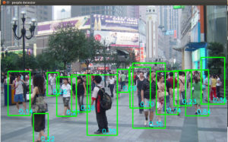

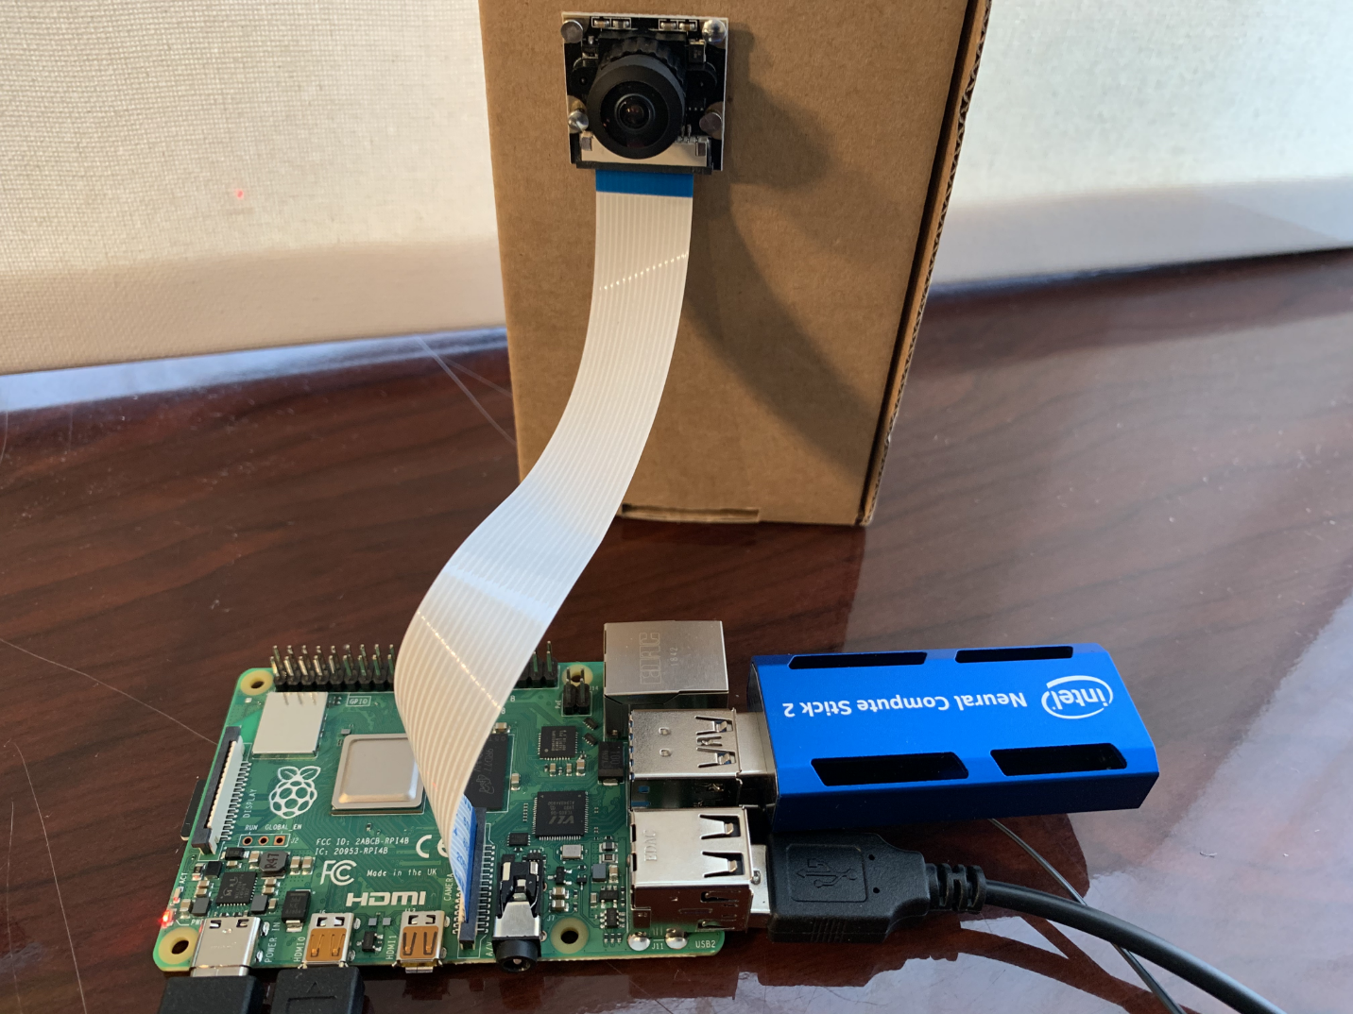

The raspberry pi-based obstacle avoiding robot consists of three main modules i.e., camera module, raspberry pi, motor drivers. The camera module gets the input image which are obtained during real time operation. The raspberry pi is a platform consisting of all necessary hardware module assembled on it. It receives the images from the camera module. It carries out image processing and checks whether there are any obstacles in path of the robot and if any obstacle occurs then it will send the signal further to motor driver accordingly. The motor driver actually of two sub motors- left and right motor. These motors receive the signal from raspberry pi in case of any appearance if the obstacle in its path the motors work accordingly to signal and moves in left or right direction with the help of the left and right motor to avoid obstacles.

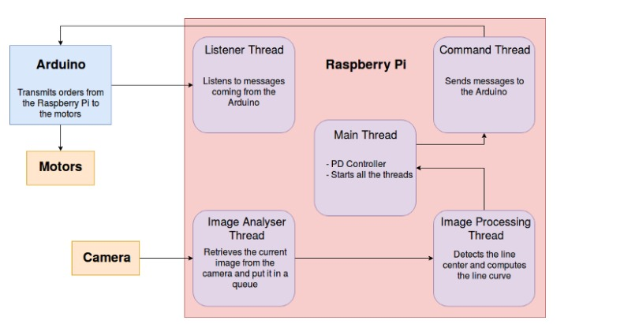

There are two versions of the Camera Module:

* [The standard version](https://www.raspberrypi.org/products/camera-module-v2/), which is designed to take pictures in normal light
* The NoIR version, which doesn’t have an infrared filter, so you can use it together with an infrared light source to take pictures in the dark

# Tasks in this week

* [#50] object detection and identification
* [#51] raspberry pi and Arduino mega connection
* [#26] obstacle avoidance using computer vision

# Timeline

|  |  |  |
| --- | --- | --- |
| Month | Intern week | Tasks |
| Jan |  |  |
| Week 1 | Identification of parts and drawing of the chassis diagram. |
| Week 2 | Circuit diagram and acquisition of parts. |
| Week 3 | Definition of the path to be followed by the robot car.  Laser cutting of the parts. |

|  |  |  |
| --- | --- | --- |
| Feb | Week 4 | * Assembly of the robot * Ultrasonic program implementation |
| Week 5 | * GPS and compass navigation * Path definition |
| Week 6 | Object identification using computer vision. (Raspberry pi & camera) |
| Week 7 | Transmission of live feed and data from the robot  (transmitter and receiver) |
|  | Week 8 | Implementation of tillage program on the robot (gathering and casting). |
|  |  |